Text Mining Project

Ofir Marcus 201618469
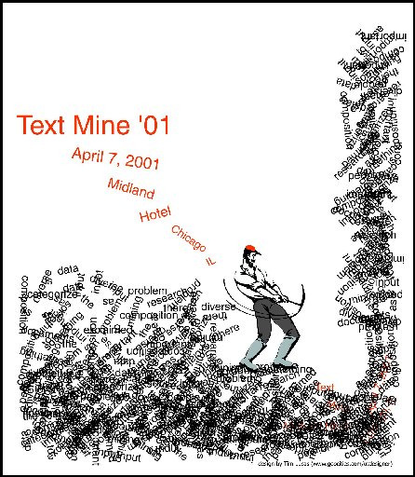
Eliezer Steinbok 336181490
Danit Lev 301643441
Talya Sohlberg 021987631

Introduction
Text mining is one of fasted growing fields of computer science in the last decade. The field gives a whole new meaning to types of data that were neglected before and helps us find "hidden" patterns in raw data.
Sentiment analysis is a sub-topic of text mining. The purpose of sentiment analysis is to determine the attitude of the speaker concerning some topic or context. Sentiment analysis is used in various fields as a data analysis tool. As new media types emerge and new platforms become available for people to express their opinion, sentiment analysis steps in with automatic tools to analyze different types of written data.
Our project consists of a system that performs sentiment analysis on stock Tweets, based on data from StockTwits.com. StockTwits is based on the extremely popular Twitter which is a platform allowing people to share and express their opinion on events or topics. Hundreds of millions of Tweets are posted daily on Twitter with each Tweet containing under 140 characters. StockTwits.com is less popular than Twitter, but the site still has thousands of Tweets per day. These Tweets are enough to express a sharp opinion over a topic. Assuming there is a correlation between people's opinion (and Tweets) about a stock and that a Tweet may influence other people, StockTwits data may be extremely valuable for trading stocks.
Our system attempts to evaluate the sentiment of a stock based on Tweets and can be used to make predictions of future fluctuations of a stock price.
The data we used in the system includes two years of all the Tweets on StockTwits.com that mention a publicly traded US company.
The input to our system is a Tweet and the output is a sentiment for each ticker mentioned in the Tweet. The sentiment is one of the set: {very positive, positive, neutral, negative, very negative}.
Analysis method
We will now explain the technical details of the implementation of our sentiment analysis system.
One of the major challenges of analyzing Tweets is that people write in a very terse style of language. Since Tweets are limited to 140 characters, Tweets usually contain grammatical errors, spelling mistakes and slang. For this reason and others, analyzing Tweets with POS (Part Of Speech) taggers or semantic parsers is extremely difficult as most of them assume a perfectly written text.
Another challenge one encounters when attempting to analyze Tweets is that some Tweets contain multiple tickers and a different sentiment must be given to each ticker in the Tweet. This requires breaking the sentence up into its different parts. We solved this problem by declaring a list of “separators”. These are characters and words which break up a sentence into multiple parts. A simple example of a separator is a single period (“.”). We assume that each side of the period refers to a different ticker. If two tickers appear in the same part of a sentence we give each ticker the same sentiment. If after we have split the Tweet into multiple parts there are no tickers in a certain part of the Tweet, we ignore this split. We only split Tweets into multiple parts if the Tweet contains more than one ticker.
For example, the Tweet: “$AAPL's iPhone 5 sucks. I like Nexus 4 $GOOG much more” is split into two parts: “$AAPL's iPhone 5 sucks” and “I like Nexus 4 $GOOG much more”. The separator in this example is a period and our system analyses each part separately, giving $AAPL a negative sentiment and $GOOG a positive one.
TODO
After we have split the Tweet up into its multiple parts, we replace all abbreviations with their unabbreviated form. For example, “OMG” is replaced with “Oh my God”. “R” is replaced with “are”. “U” is replaced with “you”. The replacement is done using a dictionary called the SlangLookupTable. This dictionary simply maps abbreviated words to their full, unabbreviated form. This stage is very important for analyzing Tweets because Tweets are written in informal language and often contain abbreviations.
The final stage is to actually give a sentiment to each ticker in a Tweet. To do this we used a file called EmotionLookupTable. This is a dictionary that maps words and prefixes to integer scores. The scores are in the range -5 to 5. The dictionary was based off of data from SentiStrength, that we changed slightly by hand. An example of the sort of changes we made was with words such as “kill” or “revolution”. For good reason, SentiStrength gave these words negative scores, but in the context of stocks, our analysis of Tweets showed that these words were often used in a positive context. Common examples of these words being used in stock Tweets are: “$AAPL is making a killing” or “The $GOOG revolution continues”. Consequently, we changed the scores for these words. Furthermore, there were some very important stock related words that did not appear in the SentiStrength word list. Some very important words that we added to the dictionary were “bullish”, “bearish”, “bull”, “bear”, “long” and “short”. These words appear very often in Tweets about stocks and are very helpful in analyzing the sentiment of a stock.

We also removed from the list words that have a sentiment in regular Tweets, but neutral in business Tweets. In example: knife, kiss*, etc. There was a special case we found in the procedure of determining word sentiments, and it concerns the word 'like'. Like has a positive sentiment when it refers to the relation of the writer to the topic, but in many cases it came after the word 'look/s' it has no meaning. We treated that case specially and ignored the sentiment of 'like' in that context.
Booster and negation words
There is a special family of words that we refer as 'Booster words'. Booster words are words that increase the sentiment of an emotion word that comes after them. We considered a word a as booster only if it is at most 2 words before the sentiment word. Example to the booster calculation: Very very good - the double occurrence of the word 'very' adds 2 points (twice 1 point) to the sentiment of the word good (originally had a sentiment of 2). Similarly, for 'Very very bad' the combined score is -4.
Negation words are another special family of words. These words flip the sentiment of words that come after them. We consider these words also only if they come at most 2 words before a sentiment word. If we have 2 words in a row, they cancel each other.
In our experiments we found another powerful amplifier which is exclamation mark. We found that when at least 3 exclamation marks come in a row in the end of the sentence, it acts like a booster on the sentiment of the whole Tweet (and not on a single emotion).
Emoticons
An important feature of Tweets, that doesn't exist in full articles, is emoticons. Emotion icons are a common way of people to express their feeling and signal their sentiment. In our system, the common ':)' smiley gets a +1 sentiment.
Total score
The total score of the Tweet was determined by summing all sentiment words, after all the steps we introduced.

Demo
The red graph represents the sum of negative Tweets for each date, while the blue one represents the positive Tweets for each date.
GOOG ticker 10.09.09 – 05.11.09
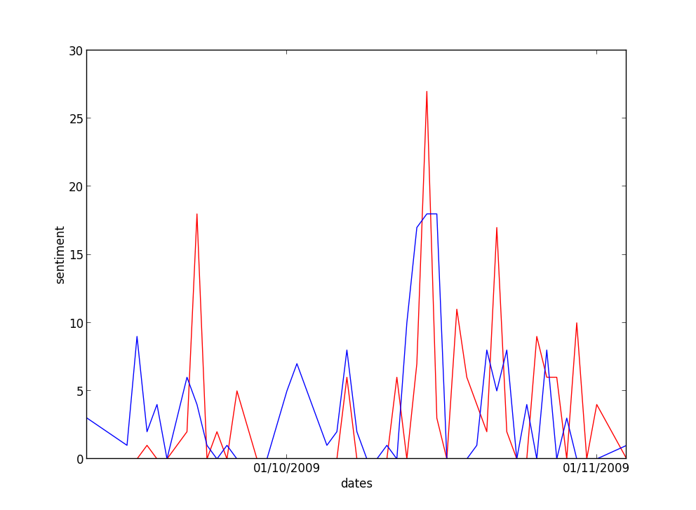

Final Remarks
- We attempted to analyze the stock Tweets using a database of phrases (2 words or more) with their sentiment. The database is originated in opfine.com which is a popular stock sentiment analysis site, based on stock related articles. We found that none of the Tweets contain any of the phrases we explain that by the informal language used on Twitter and stock-Tweets.

- People sometimes mention specific values they believe that the stock will get to. A text mining system cannot "understand" the sentiment of such thoughts as it doesn't contain any technical details about the stock. For example our system returns: "<neutral>$GS 183.26 </neutral>". If we knew $GS previous value we could figure out the sentiment of the sentence.

http://sentistrength.wlv.ac.uk/

